RESUME
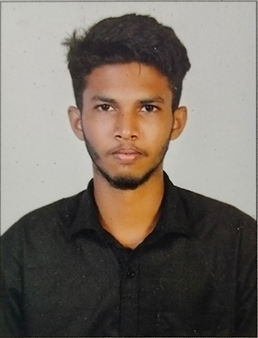
Affix your recent passport size photograph
Name: K.KALIRAJ.
Address:21,Maruthupandiyar Street,B.B.kulam,Madurai-625002.
E-mail id: kaliraj1424@gmail.com
Mobile No.: 9566564462

ACADEMIC QUALIFICATIONS:

COURSE | NAME OF THE INSTITUTION | BOARD OF STUDY | YEAR OF PASSING | MARK %
Bsc.IT | The American College | Autonomous | 2024 | 72%

COMPUTER PROFICIENCY:

Language | Proficiency
Language | Excellent | Good | Average
HTML | 
Python |  | 
CSS |  |  | 
PHP |  |  | 
JAVA SCRIPT |  | 

PROJECT WORK:

Title : Custom Online Artwork Booking Website.

Brief Description : I Create Custom Online Artwork Booking Website usingHTML,
CSS,javascript,PHP,MySQL.

Team Size : 1

OTHER PARTICULARS:
Qualities
- Digital Artist.
- Degree Completed.
- Website Developer.
- Photo And Video Editor.
Hobbies
- Drawing.
- Editing.

PERSONAL DETAILS:

DATE OF BIRTH : 24/07/2003
FATHER’S NAME : M.Karthick Kumar.
LANGUAGES KNOWN :
Language | Read | Write | Speak
English |  |  | 
Place:Madurai
K.Kaliraj

